AfiFarm TM 5.3
The industry’s ultimate tool for dairy farm management
The best sensors

VITAL KNOWHOW IN EVERY STEP

AfiAct II® - The leading cow sensor: This amazing sensor is actually 5 products in a single package:
- Super accurate heat detection
- Animal ID for the milking parlors
- Calving alert
- Rest and Wellbeing (over-crowding and bedding alerts)
- Lameness detection

VITAL KNOWHOW IN EVERY DROP
In-Line Milk Lab™ - The industry’s most advanced milk sensors: not only it measures how much milk a cow produces, it also analyze the component to know what’s in it: % of fat, protein and more.
Thanks to this unique sensor we can reliably detect:
- Mastitis
- Sub-clinical ketosis
- Acidosis
- Nutrition problems

The most user-friendly
Meet AfiFarm ABC, your all-in-one Dashboard - where every detail of “what’s happening on my farm” is one click away:
- Herd Status
- Health Management
- Insemination & Fertility
FARM MANAGEMENT HAS NEVER BEEN EASIER.

The best software for high scale farms
No other farm management has ever handled 60,000 animals in a single herd, in real time.
Worldwide Afifarm is the most trusted software among managers of large herds (above 2000 animals).

The best mobile apps
Serious management just got cooler: Two mobile apps will keep you informed up to minute:
- On important events such as difficult calving or animals ready for insemination
- On animal profiles, e.g., marking a cow for sorting if she needs attention
EVERYTHING YOU NEED TO KNOW - AT A GLANCE
ANYTHING YOU NEED TO DO - WITH A TOUCH

How it works

AfiFarm ABC
Meet AfiFarm ABC, your new farm dashboard
- Improved usability, always-on homepage
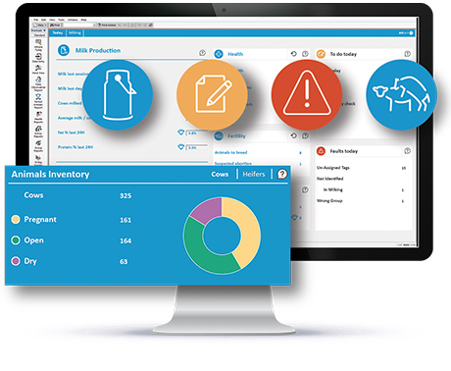
- All key management functions at your fingertips
- Always updated - reports will open in a snap, even in the largest mega-farms

What’s in it?
- Current status - inventory and production
- Attention lists - powerful system reports from Afimilk’s experts
- Action lists - tasks to perform, problems to solve

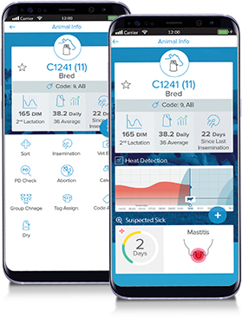
Afi2Go Pro
Everything You Need to Know - At a Glance
Anything You Need to Do - With a Touch
Afi2Go Pro (Logo) helps you spend your time where you need to be - with your cows:
- Identify a cow: use RFID wand, type her number or work by lists
- Everything you need to know: cow status, events history, and sensors data
- Everything you need to do: manage tasks, manage animals, codes, set group, sort and apply diagnosis and treatments

“Farm Notifications” Mobile App
Who's that Cow? Cow Info Mobile App
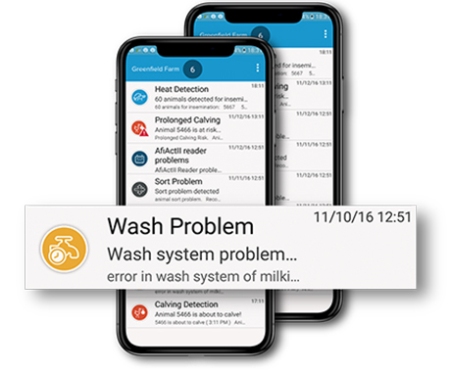
Key information at the tip of your fingers: animal status, events, and more.

Manual mode, or linked with standard RFID wands.

Stay Alert! Farm Notifications Mobile App
- Time sensitive events, are now pushed directly into your smartphone
- Displayed as splash notifications and can be browsed at all times in your farm-notification inbox
- Includes: animals for insemination, calving alerts, and system alerts

Decision Support Tool
Breakthrough in early detection - Specifies who & what
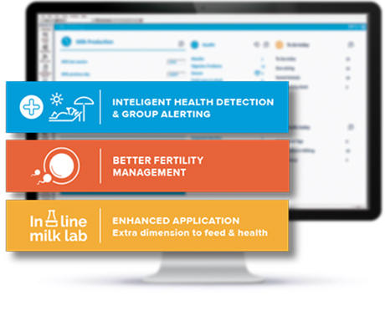
With AfiFarm, animals are treated in time, period.
The software works harder so you don’t have to. Based on powerful AI (Artificial Intelligence) algorithms, it gives you detailed actionable information:

Powerful early detection reports developed by Afimilk experts:
- Mastitis
- Ketosis
- Fresh cows diseases
- Nutrition alerts
- Anestrus cows
- Suspected abortion
- Overcrowding
- Bedding problems
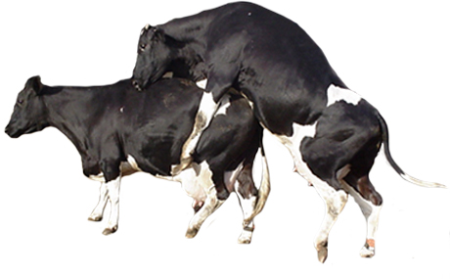
Best Time for Insemination
Find out which cows to inseminate - and when
Not only AfiFarm will help you detect animals in heat and mark them for insemination, it will also indicate what is the best timing of insemination.

- In case the farmer can influence the insemination time - achieve better conception rate
- In case insemination timing is too remote - save money and avoid useless insemination

Rotary Terminal
Eyes everywhere - without moving
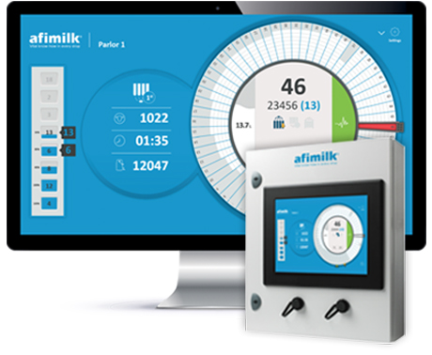
No need to walk around the parlor - everything is visible from the milker position at the first stall, or in the comfort of your office

- Intuitive touchscreen-based control keeps you on top of everything that happens in the rotary
- Status of milking session progress, groups, and production data keep you in control real-time
- Alerts on cow in wrong group, early kick-off, antibiotic code, or high conductivity, makes sure intervention is timely
- Actions such as sending a cow under attention for sorting or holding for a second rotation - a touch away

Precision Milking
Know what your milkers are doing!
AfiFarm 5.3 Milking Efficiency Module: Keeping an eye on the parlor

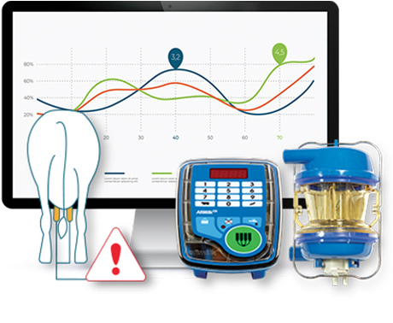
Well established milking routines, effective preparation, post-dip and equipment cleanliness are vital to milking performance. AfiFarm milking module helps coach and monitor the parlor team and has a proven record of significantly improving udder health and milk productivity.

- Parlor monitoring dashboard includes session KPIs (key performance indicators) to set and meet goals
- Quickly identify and deal with problems
- Milking preparation monitor Identify at a glance whether udder prep was optimized for each shift; compare shifts

Smart Sort
Cow insemination, treatments, vet check, pregnancy check, hoof trim, animals movement - all are daily necessities, with the first step - identifying the right cow. AfiFarm provides a top level automatic sorting solution:
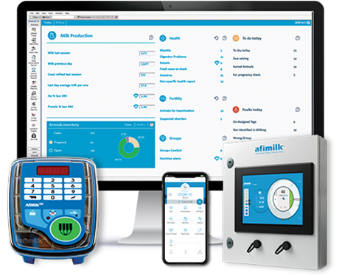
- Automation - Define and automate any routine task, sorting the relevant animals at selected times
- Flexibility - Set 2-way or 3-way gates, activities per time or day or week - the most flexible management tool available makes anything possible
- Ease of use - Automatically assign codes and sort, or indicate a specific animal via mobile app, milk-meter button, or rotary terminal

Individual Feeding
Individual Feeding Using Afifarm 5.3
Afifarm allows you to strategize, plan, and execute automated feeding programs that optimizes the feed and supplements that each animal receives according to her stage in lactation, pregnancy, yield, and body condition.

Features and benefits:

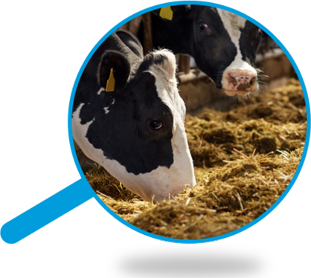
- Feed strategy per status: heifers, 1st lactation, late lactations
- ‘Special treat’: pregnant animals program
- Smart menus: automated policies by days in milk, yield, body weight and body condition score
- Safety mechanisms to avoid over-feeding, or no-feeding, daily maximum and daily minimum
- Control of distribution along the day
- Special Ketosis cows menu - treatment option (empowered by Afilab automatic Ketosis detection)

